International Civilian Peacebuilding Training Program

Participant’s Testimonials

James Aji, Political Affairs Officer, UNOWAS


“I attended the IPT Core Course for Peacebuilders at the APC in March 2023. This was my very first course at the Centre. Having previously worked in UN peacekeeping and political missions, and currently working as a Political Affairs Officer at the United Nations Office for West Africa and the Sahel (UNOWAS), the course offered me a unique opportunity to refresh, sharpen, and enhance my knowledge and skills in peacebuilding. The content of the course, including the sharing of experience with various participants from diverse backgrounds, and the real-life exercises, were particularly enriching. I left Stadtschlaining better equipped to contribute to efforts in addressing the peace and security challenges that West Africa faces. While I look forward to returning to Schlaining for other relevant courses offered by the APC, I strongly encourage people working in peacebuilding or related fields to participate in the IPT Core Course for Peacebuilders.”

Kirsty Evans, International Protection Officer, Nonviolent Peaceforce

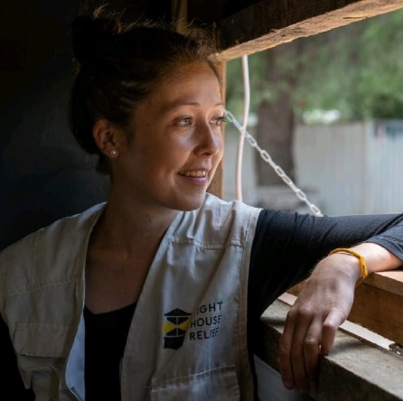
“I attended the IPT Core Course for Peacebuilders at the ACP in March 2023 as a break from my practical work in peacebuilding based in a deep field site in Jonglei State in South Sudan. By joining the IPT course in Stadtschlaining, I had time to reflect on our practices at the field level and consider them more objectively and abstractly. I could critique and present ideas in a safe space. Most importantly, I learned from those around me. Today, I feel more secure of my wider comprehension of peace, conflict, peacekeeping, and peacebuilding, and my capacity to work with others to apply the necessary interventions, to adapt and be flexible. In short, I left the training full of privilege and purpose, with more knowledge and broader understanding gained of concepts of peace on the global scale thanks to my colleagues and trainers. Learning and living with people from all over the world is a special opportunity, the benefits can be so difficult to articulate, but this diversity is what we should all strive for.”

Azeb Seifu, Monitoring and Evaluation Officer, NALA Foundation


“I had the privilege of attending the IPT Core Course for Peacebuilders at the ACP in March 2023. As an expert in monitoring and evaluation, working with international peacebuilding actors to provide support to conflict-affected populations, the course equipped me with the necessary knowledge, skills, and tools to tackle these issues and make a meaningful impact in my communities. The two weeks course was an incredibly valuable experience for me. The sessions on the peace café, complex simulation exercise, and stress management were particularly impactful, providing me with life-long skills and knowledge that I have been able to apply to both my personal and professional life. As someone working in Ethiopia, where there are numerous conflicts and challenges, the course has been instrumental in deepening my understanding of conflict analysis, mediation, and negotiation. The real-life experiences shared by both participants and facilitators also gave me a broader perspective on global issues related to peace and social justice. The interactive sessions and group activities provided an excellent opportunity to network and learn from other professionals in the field. Additionally, the ACP team is highly skilled and experienced and provided a safe and supportive learning environment. I believe that this course is essential for anyone working towards sustainable peace and social justice.”

Joseph Obiora Ezezue, Field Security Officer, UNDP

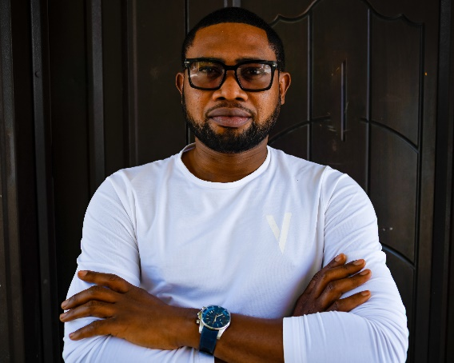
“I am a Field Security Professional with the United Nations Development Programme (UNDP) and participated in the IPT Core Course at the ACP in July 2023 because my work revolves around peacebuilding. I wanted to expand my knowledge on different peacebuilding approaches and acquire further knowledge and technical skills for the field. The IPT Course was the ultimate answer. I thoroughly enjoyed the training and smoothly sailed through the 10-days programme because it’s divided into easily comprehensible modules that kept me curious to learn more. Many thanks to the remarkable team of subject matter experts and facilitators as well as the amazing course director. The learning environment at Stadtschlaining is simply breathtaking. My professional capability and skills have improved significantly and I’ve also taken up a new position in my organisation.“

Ruvini Perera, Intercultural Dialogue Coordination Consultant, UNICEF
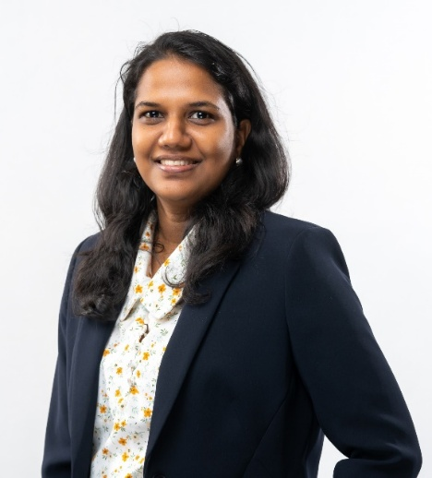
I am a development practitioner and lawyer with experience in inclusion, reconciliation, human rights, governance, gender equality and women empowerment, law reform, and public law litigation and also volunteer on law reform and peacebuilding in Sri Lanka. I decided to pursue the IPT Core Course for Peacebuilders in July 2023 as part of the professional development component of my 2023 Asia Foundation Development Fellowship. As a professional working in the multilateral sector and volunteering on the intersections of inclusion and peacebuilding, I wanted to further advance my knowledge and better understand the approaches of civilian peacebuilding. The program content was a perfect blend in terms of understanding the theoretical aspects, and acquiring practical skills required for civilian peacebuilding professionals. What was most appealing to me was the quality of the trainers and the diversity of the participants, bringing together professionals from conflict-affected countries across the world. I learnt so much both from the trainers as well as from the experiences of my peers. Moreover, the theoretical aspects I learnt from this training proofed very useful for my current work on contributing to designing programs on the intersections of inclusion and peacebuilding and have also applied some of the tools and methodologies I learnt in my work as a volunteer advocating for the necessary reforms to establish durable peace in Sri Lanka.

Aleksandar Ivanov, Full Professor, University of St Kliment Ohridski Bitola in Skopje
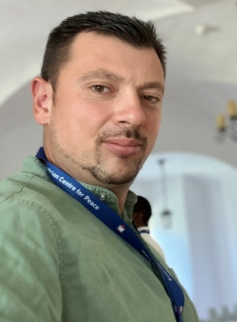
“It was a unique opportunity to be a participant at the IPT Core Course for Peacebuilders in July 2023. As a professor of International Relations and Environmental Security at the Faculty of Security in Skopje, I found the content of the course particularly useful and closely related to its practical application in peacebuilding work. My experiences from this course range from: proficient organization, high quality course program, very experienced lecturers and trainers, and the application of various techniques and learning methods, including complex simulations. The balance between the Austrian discipline on one hand, as well as the skill to create a safe environment free from prejudices and stereotypes for learning, is unique to me. Sharing experiences with people from all over the world showed that we essentially share similar challenges, but more importantly, also share a universal humanity. Without hesitation I recommend this course to all who work in the field or want to build their professional capacities in peacebuilding.”
Essie Opoka, International Rescue Committee, Training and Capacity Specialist for Humanitarian Action
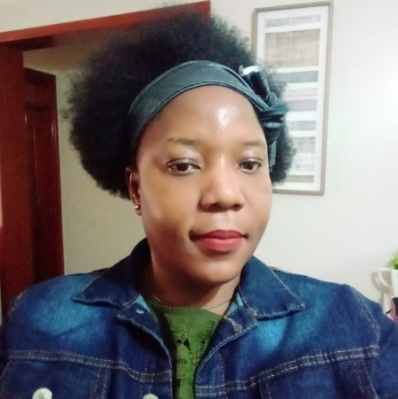
„I am a Training and Capacity Specialist for Humanitarian Action with the International Rescue Committee and have worked for over 10 years in Humanitarian response in various fields and regions globally. I attended the IPT Core Course for Peacebuilders in April 2024 and found it very useful for humanitarian work and personal development. In my opinion, one of the things that holds humanitarian actors back in their conflict analysis is that they tend to rely on traditional approaches aimed at informing peacebuilding, which are often insufficient or unhelpful when applied to regionalized or internationalized conflicts. At the IPT Core Course I learned about more creative and adaptive approaches that can be applied in different conflict contexts. The diversity of the course participants and the experience sharing were awesome – not to forget to mention the great team of facilitators with enormous knowledge and skills. I would like to encourage more humanitarian workers to participate in this training as we need creative approaches to bring hope and peace to an increasingly unpeaceful world. After the training, I am confident and full of ideas on how to integrate peacebuilding strategies that are more contextualized in the capacity-building guidelines of the organization I work for.”

Saeed Sankus Abdi, Associate Stabilization Coordination Officer, UNSOM

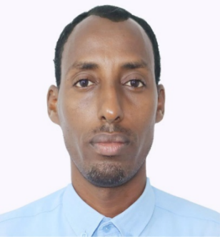
As a National Stabilization Coordination Officer with the UN Mission in Somalia (UNSOM), I focus on coordinating the stabilization and early recovery efforts between the government and stabilization partners in one of the most insecure contexts in the world. In April 2024, I took part in the IPT Core Course for Peacebuilders at the ACP to enhance my understanding of various peacebuilding methodologies and to gain additional expertise and technical skills applicable to my work. With well-experienced and knowledgeable facilitators, the IPT course was the perfect fit for my objectives. The carefully chosen venue and the well-structured modules and sessions added immensely to my experience. The presentations, the group work, and the simulation exercise all had their intended impact on me. In addition, the participants - a dynamic team from different contexts and professional backgrounds - made the 10-day program especially rewarding. As I look forward to using the skills I obtained during the training in my line of work, I would like to thank the amazing team of facilitators, my fellow participants and the dedicated organizing team of the ACP for making the training a success.

Maumil Mehraj, Oral Historian and Memory Studies Researcher
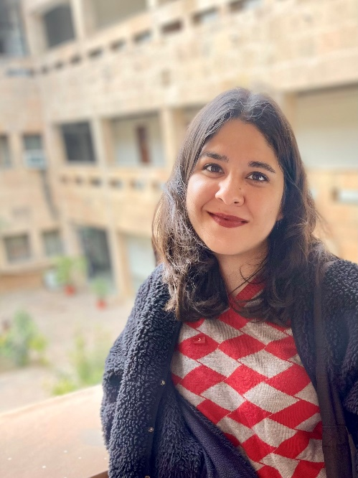
“Attending the IPT Core Course for Peacebuilders in April 2024 was a pivotal experience for me. As an Oral Historian and Memory Studies Researcher, I often felt a gap between academic theory and practical peacebuilding. This course integrated theory with hands-on training, offering insightful modules on crucial topics like gender dynamics, do no harm, and transitional justice, alongside immersive peace mission simulations. Interacting with a diverse group of participants and lecturers enriched my learning and exposed me to both local and global contexts of conflict, peacebuilding, and peacekeeping. Through in-depth conflict analysis sessions, I gained the ability to employ various lenses to conflict analysis that I otherwise was oblivious to. More than all else, I formed lasting friendships and connections during the course, which underscored the importance of networking and collaboration in professional development. The course not only deepened my understanding of peacebuilding but also revitalized my approach to academic research.”

Kamilla Ibragimova, National Programme Officer at the OSCE Programme Office in Bishkek


“I am a National Programme Officer at the OSCE Programme Office in Bishkek, working on projects focused on strengthening connectivity in the region through academic and professional exchange on issues related to politics, gender, environment, and development. I attended the IPT Core Course for Peacebuilders organized by the ACP in April 2024 as a part of my learning and professional development. The intense and interactive programme of the course equipped participants with important theoretical and practical skills in peacebuilding. As I had limited expertise in peacebuilding prior to the training, it was a fascinating opportunity to learn from the excellent trainers and hear about the experiences of my fellow course mates from different parts of the world. I truly believe that this course is important for those who work or wish to work in international organizations, as it provides a great basis for future professional endeavors in the field of peacebuilding and development.”

Aristide Mama, Community Development Specialist


“In 2017, I participated in my first IPT training organized by the ACP on conflict-sensitive project management. In 2024, as I continuously seek to further strengthen my ability to support vulnerable communities, my choice naturally gravitated towards the IPT Core Course for Peacebuilders. This training was the ideal opportunity for me to deepen my skills and reinforce my commitment to impactful peacebuilding. With a background in community development, I have built a career dedicated to solving fundamental and complex community problems. My participation in the IPT Core Course for Peacebuilders stemmed from my desire to deepen my skills and to gain practical tools for supporting peace work in post-conflict environments. The training exceeded my expectations, providing a powerful blend of hands-on exercises, real-world case studies, and expert input that enhanced my understanding of how to handle complex challenges in peace work. I intend to apply the learnings acquired during the training in my current role as well as in future peacebuilding initiatives, by enhancing my approach to project planning and monitoring and by ensuring that my efforts are both impactful and aligned with the needs of conflict-affected communities”

